# Guided Capstone Project Report

Our client, Big Mountain Resort in Montana, has reached out to us looking for a data-driven strategy, to validate their business strategy, for placing ticket prices. So far, they are charging a premium above the average price for the tickets but the business has a suspicious that Big Mountain is not capitalizing on its facilities as much as it could. They have an immediate challenge, which is, to cover for the new operating cost resulting from installing an additional chair in the mountain.

In order to help Big Mountain Resort, we built a Machine Learning prediction model to identify the features that are more relevant for pricing allocation and be able to propose a data driven ticket price.

We extracted a concentrate of information from a CSV file provided by the resort, which contained information of 330 resorts around the US, containing information of 27 features, including, resorts location, their elevation, lift chairs available in the resort, runs, terrain, amount of snow they make, days opened last year, ticket weekday/weekend passes and skiable area, among others.

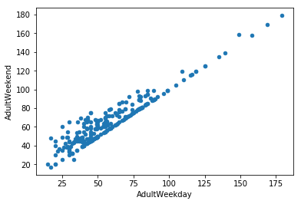For the analysis, we focused in the price for the weekend ticket, since we had more information about that price. We cleaned the data from entries that were missing in the majority of resorts, such as fastEight (the number of eight person chair) and also cleaned the data from resorts that were missing in both the weekend ticket price as well as the weekday ticket price, since they were useless for our analysis. We also added information about the state population from [Wikipedia](https://simple.wikipedia.org/w/index.php?title=List_of_U.S._states&oldid=7168473) in order to include the market size (population in each state) in our analysis.

As an interesting point we found is, that in general, the price of the ticket between the weekend and the weekday price is the same for tickets over $100, but it is sometimes different for tickets under $100, being the weekend ticket higher than the weekday ticket.

The features in which Montana excels among other states are:

* Larger State Area. The third one in the list, right after Alaska and California. But, when considering the number of **resorts per 100k square mile**, Montana is not in the top 5, meaning, there are not as many resorts in the state as in other states based on the state size.
* Number of **resorts per 100k capita**, it takes Montana to the fourth place below Vermont, Wyoming and New Hampshire.
* **Skiable area**, Montana is the forth in this category.

There are some features that Montana is not as strong as other states:

* Colorado is not in the top 5 for larger **night ski area** (lighted trails). It fell to position 12.
* Also, the number of **resorts in the state** is low, only 12. While New York leads with 33 resorts in its state.
* **Total days open** during last season, Colorado takes first place, with 3258 days among the resorts in the state.
* Montana does not have many **terrain parks**, it only offers 27, when California (the leading state in this category) offers 81.

We constructed a correlation map and found out which features influence that most in ticket pricing:

|  |  |  |
| --- | --- | --- |
|  |  |  |
|  |  |  |
|  |  |  |

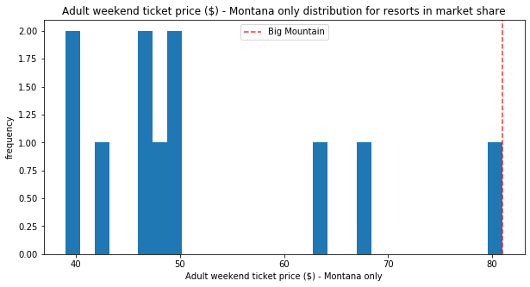

Then we built a ML model to make a prediction on what would be the best weekend ticket price for Big Mountain resort and what is the acceptable margin of error on this prediction. The results were that: **Big Mountain Resort modelled price is $95.87** (actual price is $81.00) with the expected mean absolute error of $10.39, which means, there is room for an increase. This would bring the resort in the state to the high end, but it is justified!

Now, regarding the suggestions of potential scenarios for cutting costs:

1. Permanently closing down up to 10 of the least used runs. The model says closing one run makes no difference. Closing 2 and 3 successively reduces support for ticket price and so revenue. If Big Mountain closes down 3 runs, it seems they may as well close down 4 or 5 as there's no further loss in ticket price. Increasing the closures down to 6 or more leads to a large drop.
2. Increase the vertical drop by adding a run to a point 150 feet lower down but requiring the installation of an additional chair lift to bring skiers back up, without additional snow making coverage. This makes no difference is the price estimation.
3. Same as number 2, but adding 2 acres of snow making cover. This makes no difference in the price estimation since the area is pretty small.
4. Increase the longest run by 0.2 mile to boast 3.5 miles length, requiring an additional snow making coverage of 4 acres. Makes no difference in the estimation.